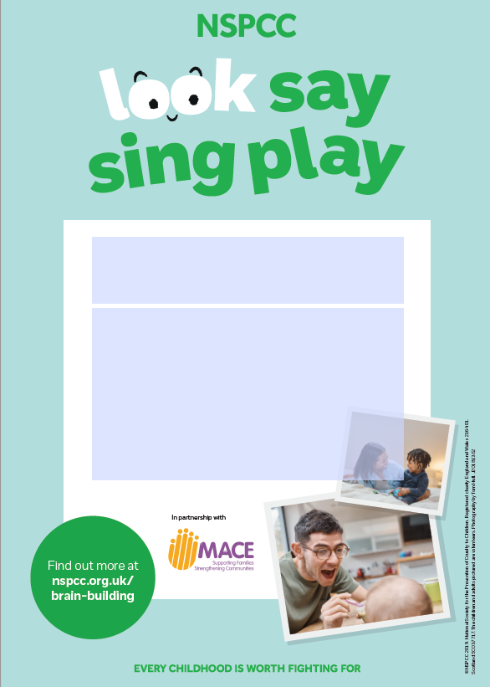

* Look, Say, Sing, Play is all about simple, fun activities that fit in to your routine and support your child’s development.
* Join us on Wednesday 9th Sept 10.00-10.30 am to find out more about supporting your child’s development.

*To register for this Webinar (Zoom) email:*

Donna.mcgee1@tusla.ie

**Look, Say, Sing, Play**

**Parents Webinar –Strabane & Donegal**