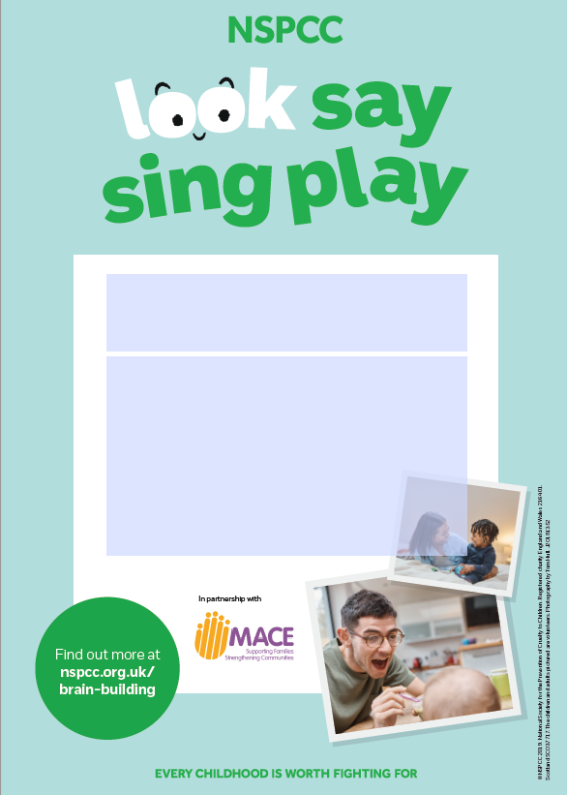

* Look, Say, Sing, Play is all about simple, fun activities, which support children’s development whilst fitting in to family routine. If you would like to support families you are working with to access this programme join us on Friday 4th Sept 9.30-10.30 am to find out more about our joint campaign.

*To register for this launch event (Zoom) email:* donna.mcgee1@tusla.ie

**Look, Say, Sing, Play**

**Launch Invite –Derry, Strabane & Donegal**