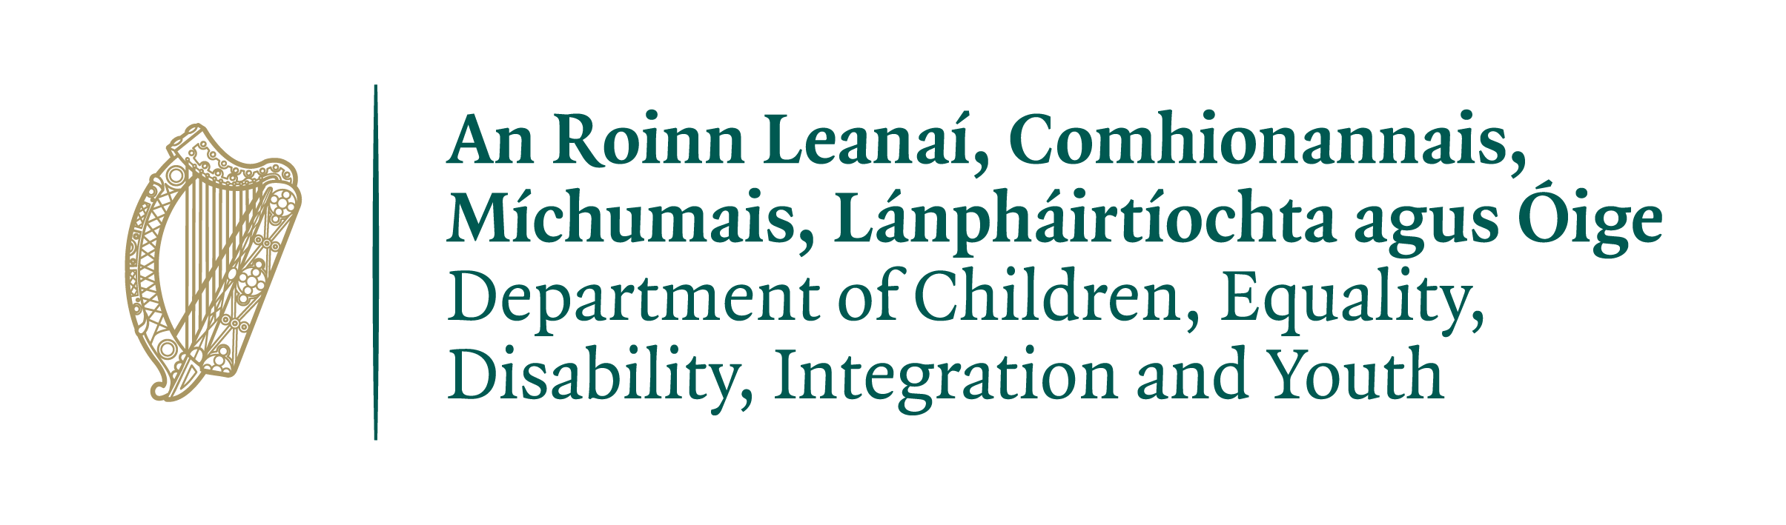

COVID-19 IMPACT SUPPORT
For
Early Learning and Care Services and
School Age Childcare Services

Eligibility Checklist
2021

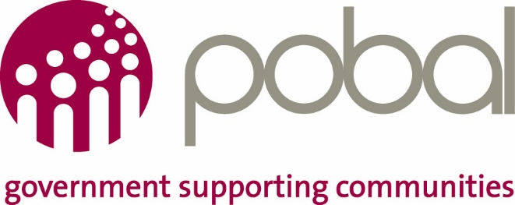

Useful Information about the process.

You must complete a self-assessment Income and Expenditure template provided by the City/County Childcare Committee to determine your organisation/business is in deficit.
This eligibility checklist is then completed by the City/County Childcare Committee via a phone call with the owner or board member (or designated authority of the board) of the Early Learning and Care Service and or School Age Childcare Service.
For multiple service owners, an eligibility checklist must be completed for each facility that you are seeking support for. Applications from multiple service owners will be considered collectively.
The completed eligibility checklist will be sent to you via e-mail by the City/County Childcare Committee.
The owner/board member or designated authority is required to review the completed information, confirm the information herein is correct and sign and return to the City/County Childcare Committee.
On receipt of the signed Eligibility Checklist you will be sent an application form, guidelines and occupancy workbook for COVID 19 Impact Support.
Please note the following:
- You will be required to submit bank statements for all accounts associated with your business or organisation or company.
- Failure to complete the application form as per the application guidelines will result in your application form automatically being deemed invalid.

Early Learning and Care or School Age Childcare Details

Service Name
DCYA Reference Number
Email address
Name of applicant

Eligibility Checklist
ELC: Early Learning and Care SAC: School Age Childcare
1 | I/We have completed the self-assessment Income and Expenditure Template provided by the CCC and confirm that it results in an overall deficit for the organisation as a whole.
2 | I/We have completed the self-assessment Income and Expenditure Template provided by the CCC and confirm that it results in a deficit, which is great than €1000 when only income and expenditure related to the provision of childcare is taken into account.
3 | I/We confirm that our service does not have sufficient cash on hand/unrestricted reserves to absorb this deficit
4 | I/We have a current decline in income due to a reduction in occupancy as direct result of the impact of COVID-19 and will provide evidence of same.  And/or  I/We are experiencing an increase in costs as a direct result of the impact of COVID-19 and will provide evidence of same.
5 | I/we have applied for all other Government and DCEDIY schemes available to help us to continue to deliver childcare services.
6 | Is your service registered with Tusla?
7 | I/we have active contract(s) with DCEDIY to deliver one or more of the department’s ELC or SAC childcare programmes for 2020/21.
8 | Please confirm you have been advised that you will have to submit bank statements and financial information as part of your application
9 | Please confirm you have been advised that if you do not fill in the application form in accordance with the application guidelines your application will be deemed invalid and will not be processed. Clarifications will not be sought as part of this process.
10 | I/we stopped charging fees for parents that can’t avail of our service, where applicable
11 | This question is only applicable to ELC and SAC services with employees:
 | If you are a Service provider with employees please confirm that you have registered for the Employment Wage Subsidy Scheme (EWSS) operated by Revenue

To be eligible for consideration for funding you must:
- Have selected ‘Yes’ to statements 1 to 9 above,
AND
Have selected ‘Yes’ or ‘N/A’ to statement 10
AND
If you have employees, you must also
- Have selected ‘Yes’ or ‘N/A’ to statement 11 above.

Term and Conditions

- These statements have been answered via a phone call with your local CCC and have been forwarded to you by email for confirmation. It is your responsibility to ensure that the above information is correct.

- By adding your name on the next page and returning this form you confirm that the information contained within is accurate.

- Funding provided under this programme may be recouped if the above information cannot be confirmed or is inaccurate.

- If you’ve answered ‘no’ to any of the statements above then you are not eligible for funding.

- If any of the answers do not match your recollection of the call, or you believe you may have answered no at the time in error, contact your CCC to discuss amending the eligibility checklist.

Please confirm that you have read and understood these terms and conditions by checking this box:

Submitting the Eligibility Checklist

Enter the name of the person submitting the declaration
Position in the Organisation/ Business

This must be a member of the board/senior executive/owner of this facility.
If this declaration is being submitted on behalf of a board or committee, the person signing and submitting this application must be authorised by the board and evidence of the authorisation must be retained by the applicant for future reference e.g. minutes of board meeting.

If you are happy that the above statements have been answered correctly please return this document as an attachment to the declaration email that has been sent to you by your local City/County Childcare Committee.

Next Steps If Eligible,

- You will then be sent an application form, application guidelines and an Occupancy Workbook.
- Your local CCC will provide you with support if you should require it.
- Completed Application Forms and associated backup documentation must be submitted by you the applicant directly to Pobal at the email address provided in the application guidelines

