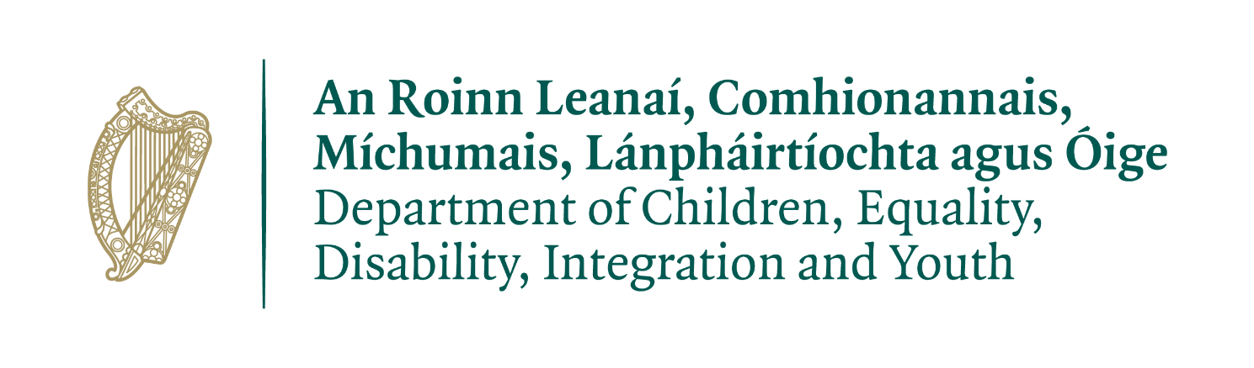

COVID-19 Impact Support
Self-Assessment Income & Expenditure
Template

This template is for information purposes only
Do not submit this form to your local County/Childcare Committee or Pobal

Section 1 Useful Information

Please read before you complete this template.

The purpose of this self-assessment template is to help you determine if you are eligible to apply for funding from Covid-19 Impact Support.
The template is for your information only and you are not required to submit the completed template to your local City/County Childcare Committee (CCC).
The purpose of this funding is to restore services that make a loss/deficit in that month to break-even level.
Funding will only be provided if your service operated at a deficit of greater than €1,000 in the application month (i.e. the month for which you are applying).
Only income and expenditure related to the provision of childcare is taken into account.
Definition of deficit:

In financial terms a deficit occurs when expenses exceed income. A deficit is a shortfall or loss and the opposite of a surplus. It will be shown as a minus figure.

To be eligible for this funding a service provider must show that:
- Your childcare expenses has exceeded your childcare income in the month you are applying for and
- Any cash on hand is less than 4 times the deficit amount to be eligible for this funding (cash relates to whole business/organisation).

For example:
- Deficit = (€1,200). Cash on hand = €3,600 eligible to apply
- Deficit = (€1,200). Cash on hand = €6,000 not eligible to apply

Please complete all the following sections of the template.

Section 2: Financial Information

2.1. Opening and Closing Bank Balances
You must provide the total opening and closing bank balance for your business.
If you have more than one bank account for your business you must provide the combined opening balance and closing balance across all bank accounts.
Owners of multiple services please note:
- You will be required to submit copies of bank statements for all accounts held by all services and parts of your organisation.
- Your applications will be considered together and not as individual applications. The financial health of your organisation will be considered in the decision for funding.

Useful Definitions
- Application Month: This is the month you are applying for in 2021.
- Opening Balance: This is the balance as at the first day of the month. Round your balance to nearest euro. This can be a positive or minus figure.
- Closing Balance: This is the balance as at the last day of the month. Round your balance to the nearest euro. This can be a positive or minus figure.
- Multiple service owners may submit an application form for any, some or all of their facilities, provided that each facility for which an application is being made is registered with Tusla and has a DCYA reference number.
You should complete the self-assessment income and expenditure template for each facility that you believe may require funding.

Please note - with each application form you are required to complete the financial information section of the application for your entire organisation as a whole and submit copies of bank statements for all accounts held by all constituent parts of your organisation and all applications for services under the same ownership will be considered for funding collectively.

Each time you insert or delete a numeric value in the tables please ensure that you use your Tab key to tab across to next cell in the table to ensure that the calculation is refreshed. This is particularly important in the last cell of each table.
B1
 | December 2020  01/12/20-31/12/20 | Application Month  2021
Enter opening bank balance
Enter the closing bank balance
Can be plus/minus figure
Difference in Bank Balances | €0 | €0

2.2 Income
You must provide the details on all your income, for your business. If you have more than one bank account for your business you must provide the combined income across all bank accounts. For multiple service owners this means you must provide the combined income for all your services.
 | December 2020  1/12/20-31/12/20 | Application Month  2021
Enter your total income from all your bank accounts i.e. as per your bank statements
Please provide a breakdown of your income.

 | December 2020  1/12/20-31/12/20 | Application Month  2021
Enter the total income from sources related to delivering ELC and SAC only
Enter total income from sources not related to delivering ELC/SAC
Total Income  The total income here must equal the total income per bank statement in the table above. | €0 | €0
2.3 Expenditure

Please complete the table below in respect of all your expenditure for your whole business/organisation for the month of December 2020 and for the application calendar month in 2021 where the deficit has occurred. You must provide the combined expenditure across all bank accounts for your business.
For owners of multiple services this means you must provide the combined expenditure for all your services.
 | December 2020  01/12/20-31/12/20 | Application Month
Total Expenditure as per bank statements
Please provide a breakdown of your total expenditure.

 | December 2020  01/12/20-31/12/20 | Application Month
Expenditure related to delivering childcare
Expenditure not related to delivering childcare
Total expenditure  The total expenditure here must equal the total expenditure per bank statements in the table above. | €0 | €0
INCOME/EXPENDITURE SUMMARY
 | December 2020  01/12/20-31/12/20 | Application Month
Total Income (per 2.2) | €0 | €0
Total Expenditure (per 2.3) | €0 | €0
Surplus/(Deficit) | €0 | €0
Please Note: Your surplus/(deficit) figures displayed above here must match the total of Difference in Bank Balances (Q 2.1).
If they do not match please review and correct your figures before submitting.

2.4 Surplus/(Deficit) Calculations – Childcare Income/Expenditure
 | December 2020  01/12/20-31/12/20 | Application Month
Childcare Income (per 2.2) | €0 | €0
Childcare Expenditure (per 2.3) | €0 | €0
Surplus/(Deficit)  Childcare Income minus Childcare Expenditure | €0 | €0

Section 3: Next Checks

- Check if Childcare Business deficit is greater than > (€1,000).
- If deficit is (€1,250) = Yes.
X If deficit is (€999) = No.

- Check if your whole business/organisation cash balance (i.e. the total bank balance at end of the application month - see B1 on page 3) is less than 4 times your deficit.
- Deficit = (€1,200). Cash on hand = €3,600 = cash on hand 3 times the deficit =Yes
X Deficit = (€1,200). Cash on hand = €6,000
The cash on hand 5 times the deficit = No.

If answers to both questions above are yes and the deficit threshold is reached please contact your local City/ County Childcare Committee (CCC) to complete the Eligibility Check.

Please Note:
While you are not required to submit the self–assessment template to the CCC, you will be asked to sign a declaration to confirm the accuracy of the figures as part the Eligibility Checklist. However, the same information will need to be provided in the application form which will be submitted to Pobal.
If your service has not reached the deficit threshold to apply, you are encouraged to continue to monitor your financial situation.
Please advise the CCC you will not be progressing with the eligibility checklist and application.
If your service moves to a position of deficit at a later date due to Covid-19 please contact your local CCC to explore funding options, which can include applying for this support again:
https://myccc.ie/where-is-my-nearest-ccc

