January 26, 2021

Re: COVID-19 Notification Assessments - Early Years Services

Dear Provider,

I hope you are keeping well. Further to my letter dated 10th January regarding COVID-19 notifications and the sustained nature of the disease in services, I am writing to advise you that we have reviewed how we manage our response to your notifications.

Over the last two years, where a service had not received an inspection since the start of the pandemic, each COVID-19 notification resulted in a remote and /or onsite inspection when there was a confirmed case of COVID-19 in a service. This is no longer necessary. Therefore, we are proposing where previously we carried out a ‘remote inspection’ we will replace it with a self-assessment checklist.

From 25 January, all Covid -19 notifications will be assessed which will result in one of the following regulatory responses:
- No further information is required - the notification will be closed out.
- The service will be requested to complete a self-assessment checklist. The early years inspector will issue the self-assessment checklist where required. Services will then provide assurance through this checklist that they have the required protective measures in place to operate a safe service. If insufficient information is returned an inspection may follow.
- The service will receive an onsite inspection, the decision to carry out an inspection will be risk based.

The revision to the process will ensure our resources are targeted where most needed and will also result in less inspections as a result of COVID-19. The COVID -19 notification form , self-assessment checklist along with other information on how to manage COVID-19 in your service is available at the following link Covid 19Tusla - Child and Family Agency

If you have any queries, please contact csroperations@tusla.ie

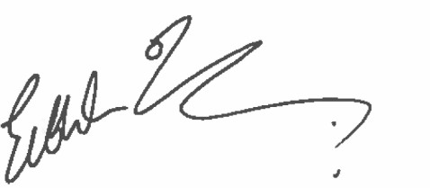
Yours sincerely,

Eibhlin O’Leary

Head of Inspection and Assessment
Children’s Service Regulation

